Touch-point one: Vision, trust and values

Introduction

Articulating a vision and purpose for integration is a hugely important part of the strategy for workforce planning. Leaders need to make clear that workforce planning is something everyone can contribute to and leads to

- Better workforce insights

- Clearer, consistent ways of planning

- Trusted sources of data

- More clarity about planning roles, responsibilities ad timelines

This simple illustration is a good example of vision and approach to workforce planning.

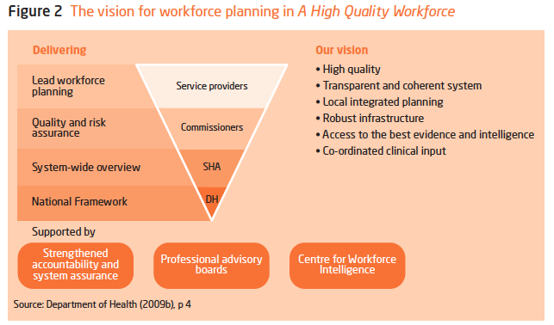
Source: Imison, C et al. (2009) NHS Workforce Planning. London: King’s Fund

Recurrent themes in addressing workforce challenges for social work and other social care professions from various countries include:

- The importance of planning and the need for a well-articulated road map for change and development for the profession
- The importance of leadership within social work to progress change, strengthen the identity of the social work and to achieve positive outcomes for service users, families and carers
- The importance of strong partnerships and collaborations in achieving outcomes for the profession and more importantly for the people served by the profession

Clear and consistent trust and permission messages need to be articulated within any vision.

These messaging should be around include: -

- confidence about values, purpose and identity
- working in true partnership with people who use its services, so that they can take control of their situation and improve their quality of life
- working cohesively with other professions and agencies in the best interests of people in need of support
- demonstrating impact and effectiveness and, therefore, public value
- committed to continuous improvement and a vigorous culture of professional development
- understood and supported by employers, educators, government, other professionals and the wider public
- well led at every level: in front line practice; in influencing the shape and priorities of local services; in setting and maintaining the highest possible standards within the profession;

Source: Cheron-Sauer, M (2012) ‘Social Work Education and Workforce Planning and Development in England, Europe, United States and Canada’, Churchill Memorial Trust

